CSA1110- OBJECT ORIENTED ANALYSIS & DESIGN
EXP -3 EXAM REGISTRATION SYSTEM
(UML DIAGRAMS)

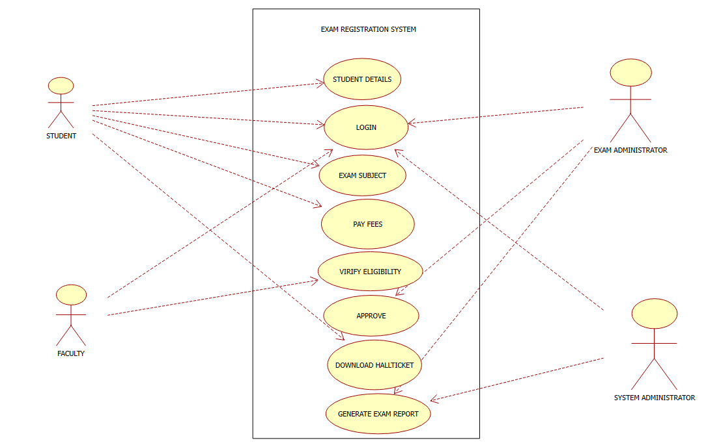

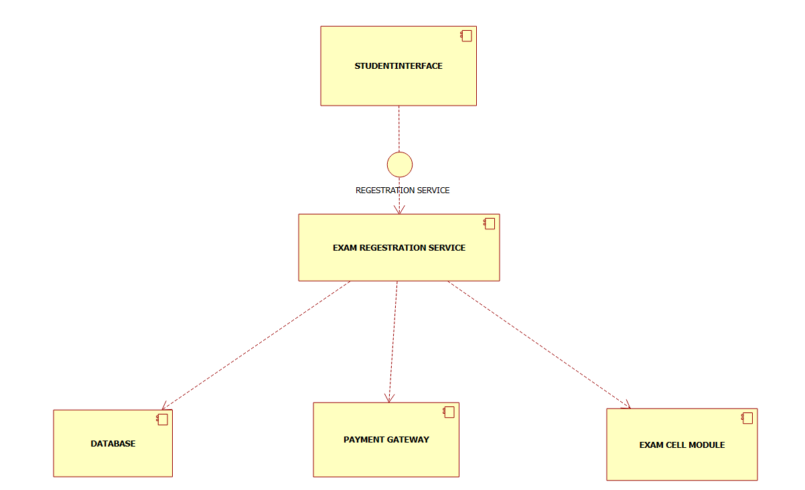

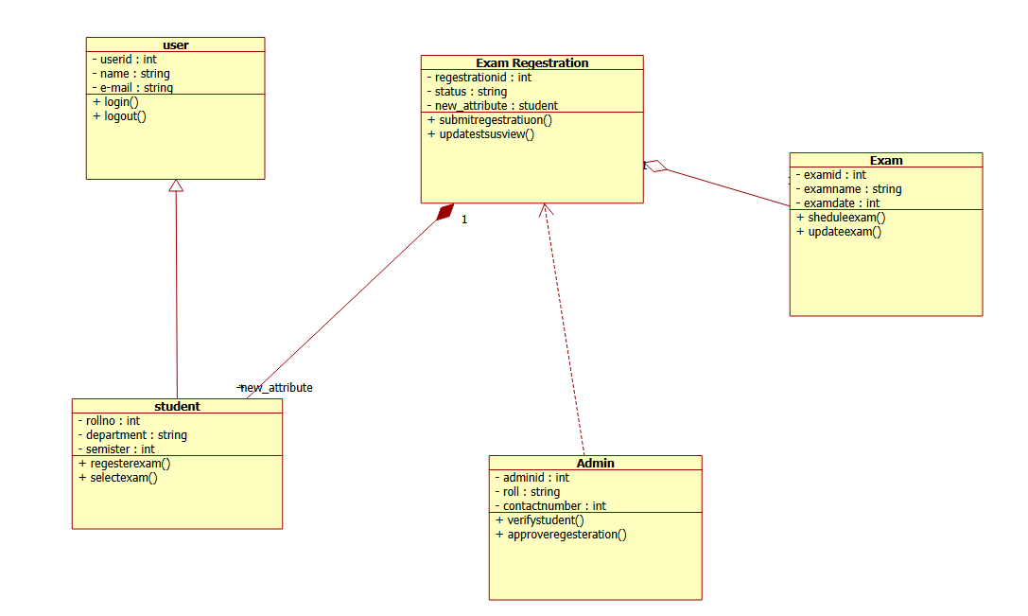

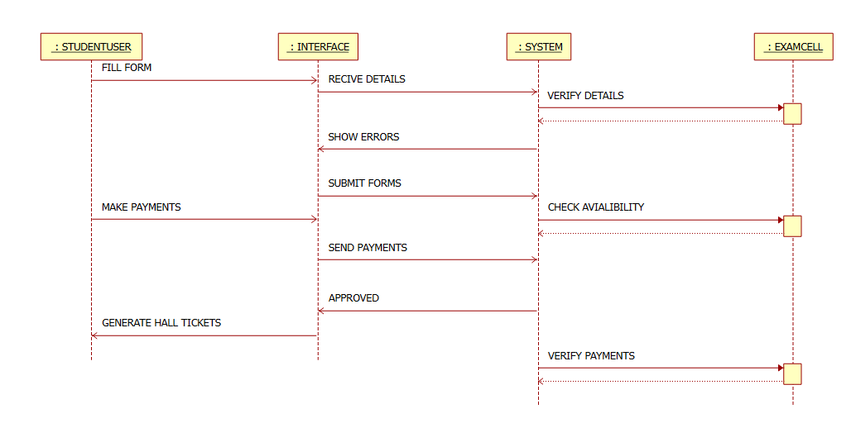

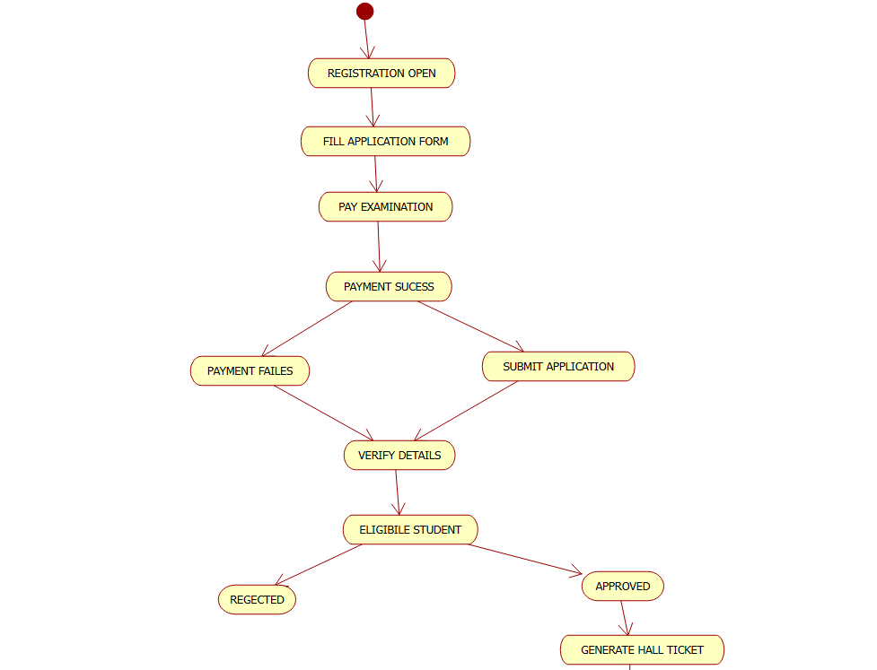

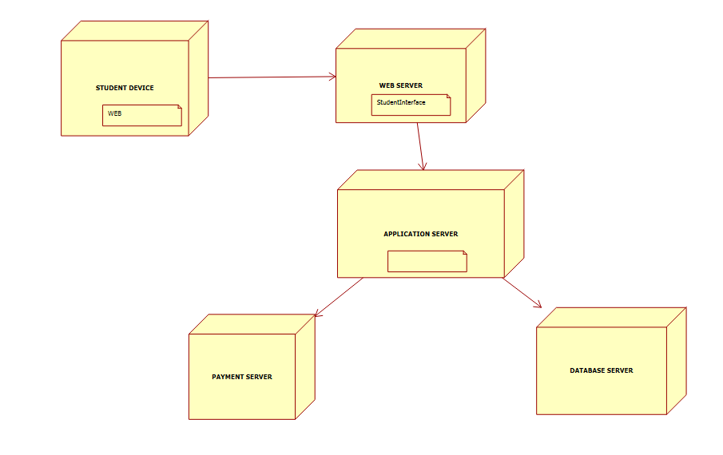
CODE

class ExamRegistration:
def __init__(self):
self.candidates = {}
self.hall_ticket_count = 1000

def verify_candidate(self, candidate_id, name):
if candidate_id and name:
return True
return False

def issue_hall_ticket(self, candidate_id, name):
if self.verify_candidate(candidate_id, name):
self.hall_ticket_count += 1
ticket_id = "HT" + str(self.hall_ticket_count)
self.candidates[candidate_id] = ticket_id

print("\nCandidate Details Verified!")
print("Candidate ID:", candidate_id)
print("Candidate Name:", name)
print("Hall Ticket ID:", ticket_id)
print("Status: Hall Ticket Issued")
else:
print("Invalid Candidate Details!")

exam = ExamRegistration()

candidate_id = input("Enter Candidate ID: ")
name = input("Enter Candidate Name: ")

exam.issue_hall_ticket(candidate_id, name)

OUTPUT

